## A preliminary exploration on positive psychological traits associated with the recovery from opioid addiction

Zhuozhuo Liu

New changes:

* Removed ‘&amp;’ in tweets and retrained word2vec models

## Introduction

Previous studies found that positive psychological traits played an important role in recovery from opioid-addiction. We would like to explore positive psychological traits of Twitter users who have recovered from previous opioid-addiction. In this study, we compared the sentiment between regular tweets posted by addicted users and regular tweets posted by recovered users and explored word embeddings between them.

## Background and previous work

Previous studies found that opioid-related social media texts may indicate meaningful insights on the opioid epidemic. Sarker et at. [1] found that the frequency of abuse-indicating tweets are correlated to the county-level overdose death rate. Besides providing geospatial-level insights, it could also provide temporal-level insights. They concluded that analyzing abuse-indicating tweets would help monitoring and predicting the opioid-abuse trend.

Many studies found that some psychological traits were associated with recovery from opioid-addiction. For example, self-efficacy, an individual's belief in his or her capacity to complete certain tasks [2], was found to play an important role in overcoming relapse of addiction during the treatment [3]. We would like to explore positive psychological traits and positive sentiments of users who are clean and sober from the previous opioid-addiction.

## Methods

3.1 Data collection

We used Tweepy, a library to query tweets from Twitter API, to fetch tweets containing at least one drug keyword posted from April 19, 2022 to April 25, 2022. We used drug keywords that Sarker et at. used which includes opioid-related drug terms (i.e., "opioid", "codeine", "heroin", "demerol", "dilaudid", "percocet", "fentanyl") and spelling variants (i.e., "codine", "herion", "heroine", "demeral", "dilauded", "dilaudud", "dulaudid", "percs", "percocets", "percoset", "fentyl").

Then we manually annotated addiction-indicating tweets and recovery-indicating tweets. Addicted-indicating tweets are tweets that indicate that users who posted them are currently addicted to opioids. For example, “i used to be the biggest pothead. but now it gives me anxiety so i do heroin'”. Recovered-indicating tweets are tweets that indicate that users who posted them were addicted to opioid but have been recovered. For example, “I was a heroin addict and lost my bf to an overdose. Now I\xe2\x80\x99m clean and sober and pursuing my dream.”.

To improve the accuracy of annotation, we had another person reviewed addiction-indicating tweets on Mechanical Turk.

Then we generated a list of addicted users and a list of recovered users respectively based on the tweets annotated. We then did a second data fetching using Tweepy and fetched the latest 100 tweets of each user in the addicted users group and the recovered users group. We ruled out retweets since we think it’s not posted directly by the user. The tweet we fetched can be either an original tweet or a reply. It can be either an opioid-related tweet or non-opioid-related tweets.

3.2 Data analysis

After having tweets posted by addicted users and tweets posted by recovered users. We did a few data analyses to compare the text posted in two groups.

We used VADER to analyze the sentiment of tweets. VADER (Valence Aware Dictionary and sEntiment Reasoner) is a lexicon and rule-based sentiment analysis tool that is specifically adjusted to analyze sentiments expressed in social media. We trained word2vec models using Gensim and visualized vectors after reducing the dimension using PCA.

## Results

4.1 Data collection

We fetched 33407 tweets after the first data fetching. We reviewed around 8,000 tweets in total, annotated 98 addiction-indicating tweets and annotated 108 recovery-indicating tweets. After having another person reviewed addiction-indicating tweets on Mechanical Turk, we had 88 addiction-indicating tweets and annotated 112 recovery-indicating tweets. There are 87 addicted users and 111 recovered users in total.

In the second data fetching, we fetched 6320 tweets from the addicted users group and 8060 tweets from the recovered users group.

4.2 User-level analysis on sentiment

In the user-level analysis, we grouped tweets by users and compared users in two groups.

We calculated positive score, negative score and compound score for every tweet using VADER. The compound score is calculated by summing all the lexicon ratings in a sentence and then being normalized between -1(most extreme negative) and +1 (most extreme positive). If the compound score of a tweet is >= 0.05, the tweet is likely to have positive sentiment. If it is <= -0.05, it’s likely to have negative sentiment. If it’s > -0.05 and < 0.05, the tweet is likely to be neutral.

We then calculated an average positive score, an average negative score for each user in two groups. We used the positive score as x axis and the negative score as y axis and generated Figure 1. Each dot represents a user. The position represents its sentiment. The figure indicated that users in the recovered group may have more positive sentiment than the users in the addicted group.

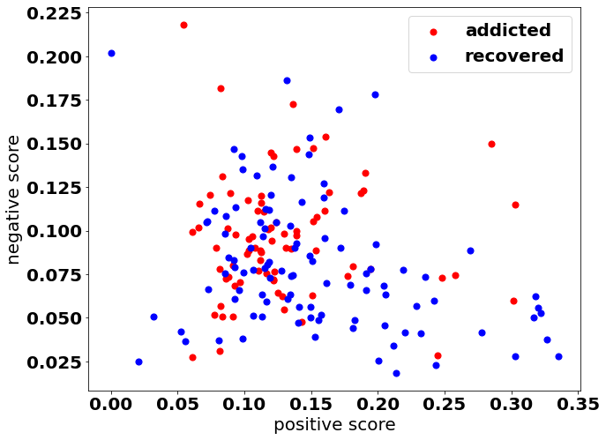

*Figure 1. Users in the recovered group may have more positive sentiment than the users in the addicted group.*

We also calculated an average compound score for each user in two groups and generated a distribution graph (Figure 2). The average sentiment score of the addicted group is 0.048 which indicates neutral sentiments. The average sentiment score of the recovered group is 0.126 which indicates positive sentiments. We did a t-test on compound scores of two groups and found that the sentiment score of the recovered group is significantly larger than the sentiment score of the addicted group (Statistics=-3.072, p=0.002). It indicates that the tweets posted by recovered users are expressed in a more positive way.

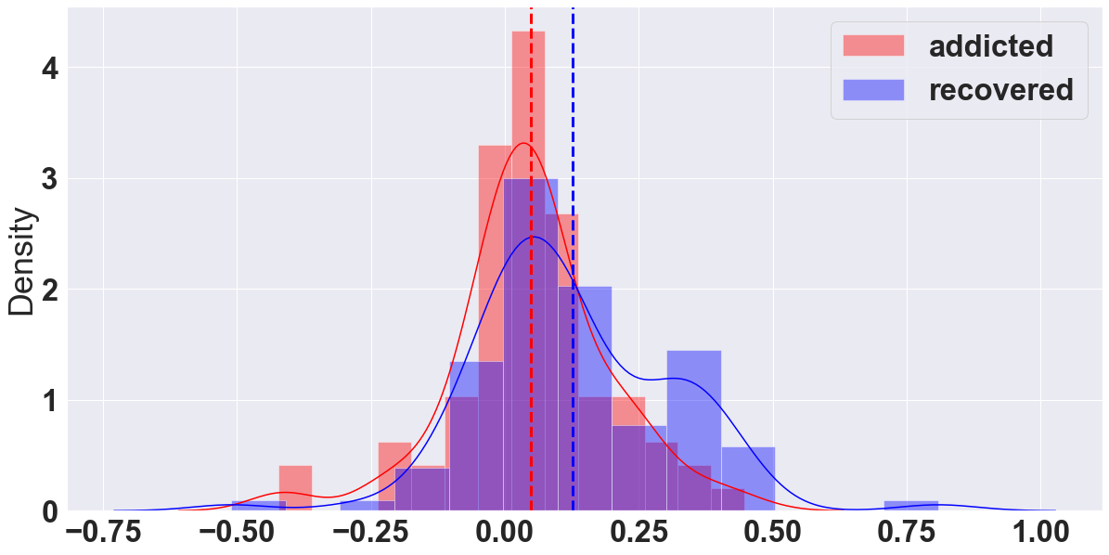

*Figure 2. A distribution graph generated by calculating an average compound score for each user in two groups. The sentiment score of the recovered group is significantly larger than the sentiment score of the addicted group.*

4.2 Word-level analysis

In the word-level analysis, we aggregated tweets in the same group and focused on comparing texts in two groups. To get corpus, we cleaned tweets by removing @username, ‘#’ for hashtags, '&amp;', stopwords and punctuation. We tokenized terms and converted all to the lower case using the NLTK library.

4.2.1 Frequency of lexicons in DUI

Drug-Use Insights (DUI) is a web application that analyzes and visualizes opioid-related social media texts [4]. It has more than 10,000 opioid-related lexicons under three categories (i.e., drug terms, drug use, drug recovery). We would like to know how users on twitter use these lexicons.

Therefore, we calculated how frequent words in DUI level one (L1) categories appear in all the tweets. Since we want to know if there’s any difference in the DUI lexicon usage between two groups, we generate a frequency bar chart (Figure 3). The number of total lexicons in the recovered group is 75824. The number of total lexicons in the addicted group is 71419. The frequency is calculated by using the number of lexicons in each category divided by the number of total lexicons.

As we can see in Figure 3, there is no significant difference between two groups on the usage of drug terms and drug use. However, addicted users used drug use lexicons (3.06%) more frequently than recovered users (2.59%) in their regular tweets. It makes sense since users who are addicted may talk more about their current situation of addiction.

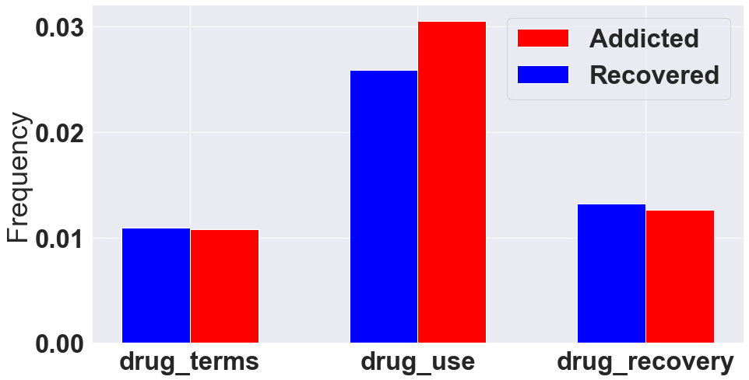

*Figure 3. Addicted users used drug use lexicons more frequently than recovered users in their regular tweets.*

4.2.2 Top 10 terms

We generated the top n terms for each group. Figure 4 shows the top 18 terms. In the addicted group, terms like ‘high’, ‘pain’, ‘sad’, ‘scared’ are related to the mental state of the addiction. In the recovered group, terms like ‘clean’, ‘sober’ are related to the recovery. There are some terms in the top terms of both groups such as ‘high’, ‘sad’, ‘happy’, ‘pain’.

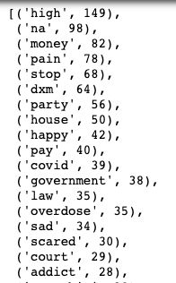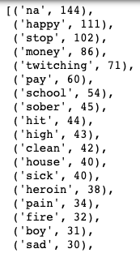

*Figure 4. Top 18 terms in the addicted group (left) and top 18 terms in the recovered group (right)*.

4.2.3 Word embeddings

Since there are some terms in the top terms of both groups such as ‘high’, ‘sad’, ‘happy’, ‘pain’, we would like to see if the same term has a different meaning between two groups. Word2vec technique enables us to represent a word in the form of a vector. It brings out the semantic similarity of words that captures different aspects of the meaning of a word. We built two word2vec models for each group using all tokenized terms in that group (ignore all terms with total frequency lower than 5). To visualize clusters and distances, we used Principal Component Analysis (PCA) to reduce the dimension of vectors of lexicons.

Firstly, we compared drug terms in DUI lexicon between two groups. Figure 5 and 6 show all drug terms that appeared in the model (with total frequency larger than or equal to 5). For the addicted group, dxm is largely different from the rest of the drug terms in terms of the meaning, which we are unsure about the reason.

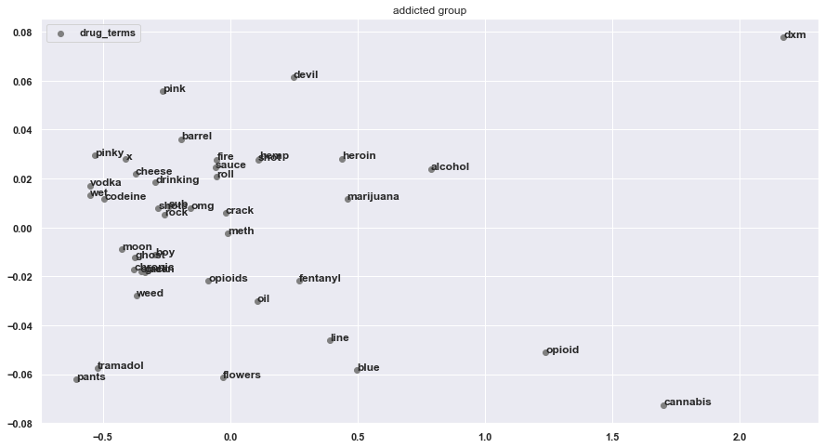

*Figure 5. Word embeddings of drug terms in DUI lexicon in the addicted group.*

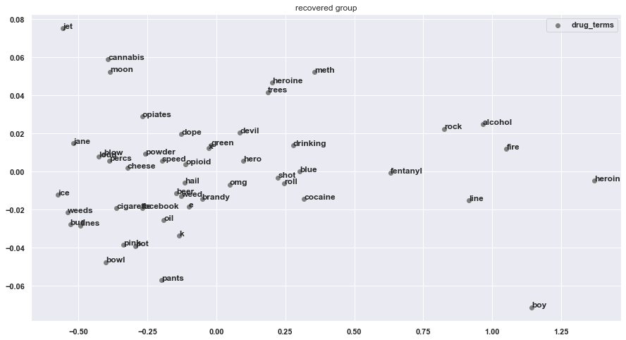

*Figure 6. Word embeddings of drug terms in DUI lexicon in the recovered group.*

Since we are interested in the difference of attitude to hardship between two groups, we drew the word embeddings of a predefined list of lexicons relevant to hardship (i.e., 'misery', 'distress', 'problem', 'hard', 'suffering', 'hurt', 'high', 'grateful', 'thank', 'appreciate' 'glad', 'hope', 'wish', 'difficult', 'difficulty', 'love', 'happy', 'death', 'die', 'dying'). Figure 5 and 6 show all drug terms that appeared in the model (with total frequency larger than or equal to 5).

We observed that the distance between ‘grateful’ and ‘difficult’ is smaller in the recovered group than the distance in the addicted group. However, similarity values of two groups didn’t differ very much. The similarity value between two terms is 0.99 for the recovered group and 0.97 for the addicted group.

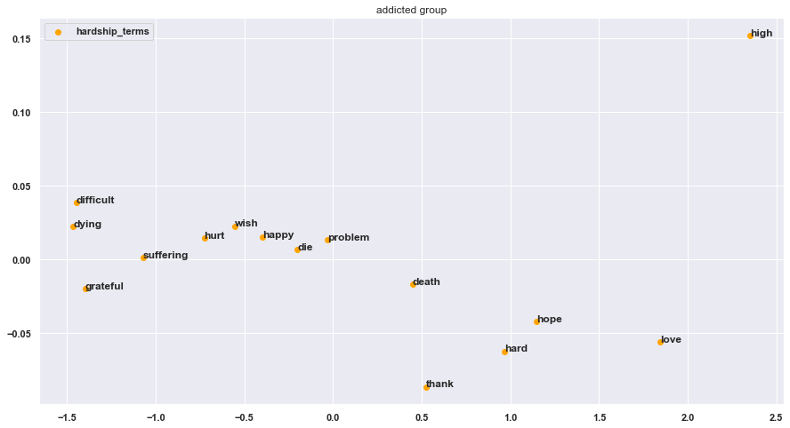

*Figure 7. Word embeddings of hardship-related lexicons in the addicted group.*

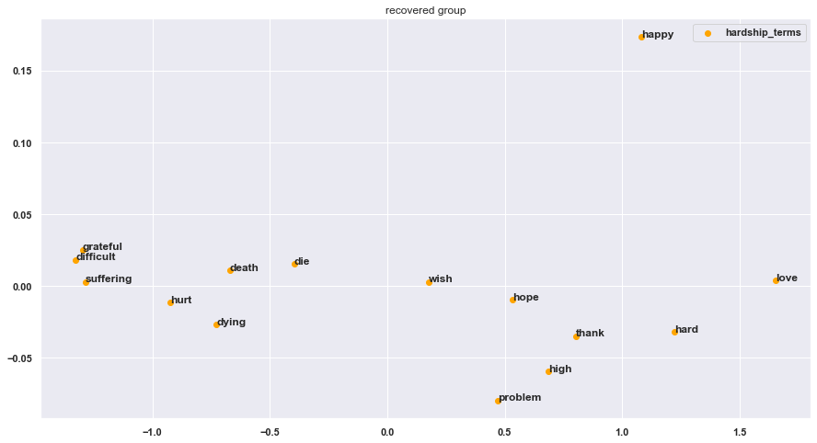

*Figure 8. Word embeddings of hardship-related lexicons in the recovered group.*

## Discussion

In this explorative study, we found a significant difference in the sentiments of regular tweets between the recovered group and the addicted group. Specifically, tweets published by users in the recovered group have more positive sentiment than tweets published by users in the addicted group. We are not sure if it’s because recovered users are positive or the addicted users are more negative. In future, we can introduce a control group whose sentiment scores can be used as a baseline.

We didn’t get many meaningful findings from word embeddings. We are still curious if the recovered group developed any new interpretation on hardship/difficulty/pain. We need a larger data set to train the model and need to find interesting words to compare.

References

[1] Sarker, A., Gonzalez-Hernandez, G., Ruan, Y., & Perrone, J. (2019). Machine learning and natural language processing for geolocation-centric monitoring and characterization of opioid-related social media chatter. *JAMA network open*, *2*(11), e1914672-e1914672.

[2] Bandura, A. (1977). Self-efficacy: toward a unifying theory of behavioral change. Psychological review, 84(2), 191.

[3] Marlatt, G. A., & Gordon, J. R. (1985). Maintenance strategies in the treatment of addictive behaviors. Relapse prevention, 383.

[4] Prince, Z., Jha, D., & Singh, R. (2021). DUI: the drug use insights web server. *Bioinformatics*, *37*(24), 4895-4897.